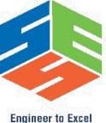
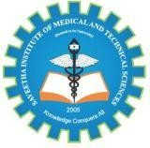
SIMATS ENGINEERING
Saveetha Institute of Medical and Technical Sciences
Chennai- 602105
Student Name: N. Goutham Reg. No: 192472024
Course Code: CSA6502 Slot: A
Course Name: GENERATIVE AI AND LARGE-SCALE MODELS
Course Faculty: Dr. NITHISHA A
Project Title: A Multi-Agent Generative AI Platform for Multi-Morbidity Conflict Resolution and Medication–Diet Interaction Verification

Module PhotoGraph

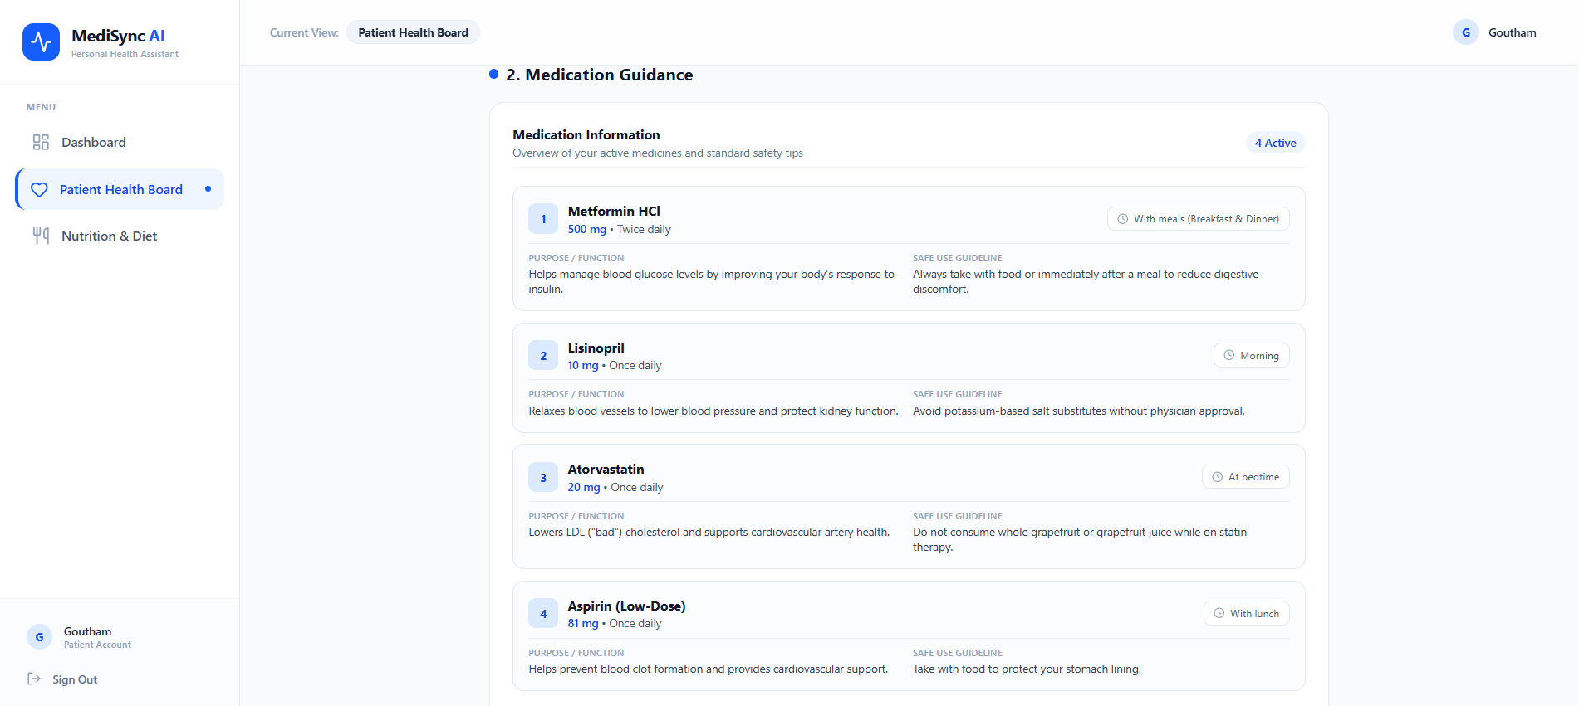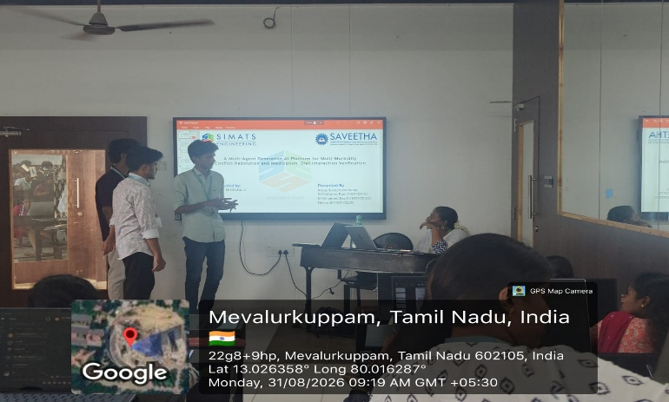

Project Description:
This project develops a multi-agent Generative AI platform to identify and resolve conflicts among multiple diseases, medications, and dietary habits. Specialized AI agents analyze medication–medication interactions, medication–disease conflicts, and medication–food interactions. The system processes patient health information and compares it with reliable medical knowledge to identify potential risks. A coordinating AI agent combines the results and generates a structured report with warnings, explanations, and safety recommendations. The platform aims to improve medication safety, reduce overlooked interactions, and support informed healthcare decisions. It serves as a decision-support tool and encourages users to consult qualified healthcare professionals before changing medications or dietary practices.

Student Signature Guide Signature

